**EXPERIMENT:5**

**Create a simple cloud software application for Mark Sheet Processing System using any Cloud Service Provider to demonstrate SaaS include the necessary fields such as name of the student, Reg no of the student, Subjects , Marks, Average, percentage, rank, overall performance etc.**

**AIM:**

To Create a simple cloud software application for mark sheet processing system using any Cloud Service Provider to demonstrate SaaS.

**PROCEDURE:**

**step1:** Go to zoho.com.

**step 2:** Log into the zoho.com.

**step 3:** Select one application step.

**step4:** Enter application name as Mark sheet processing system.

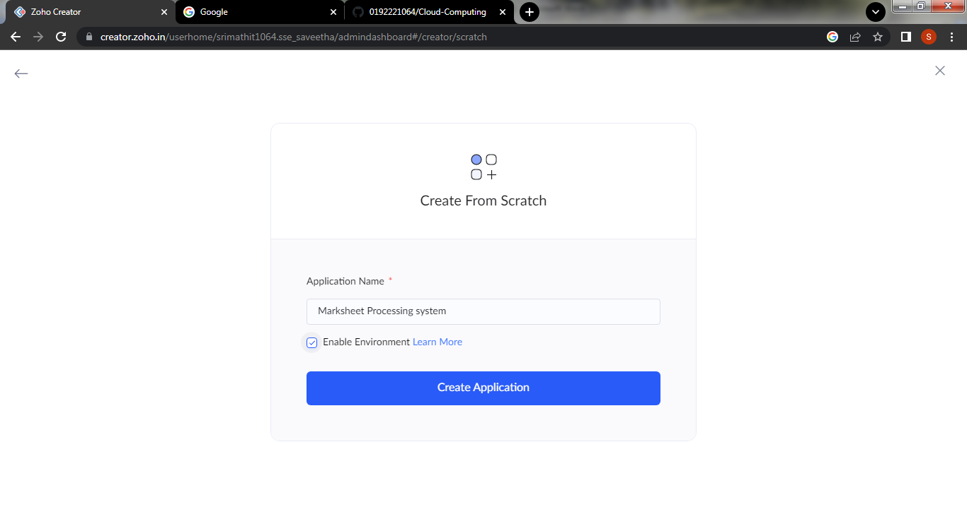

**step 5:** Created new application as Mark sheet processing system.

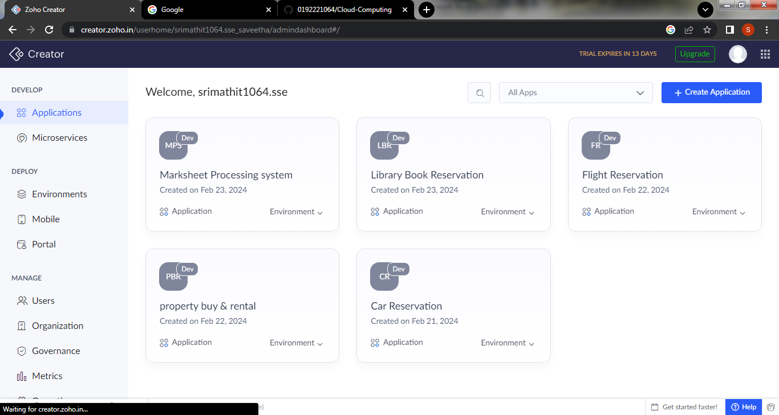

**Step 6: create a form for student details**

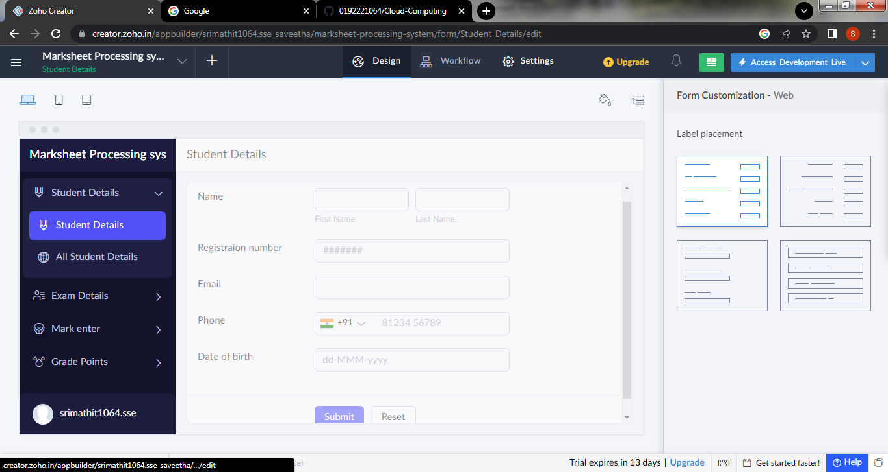

**Step 7: create a second form for Exam details**

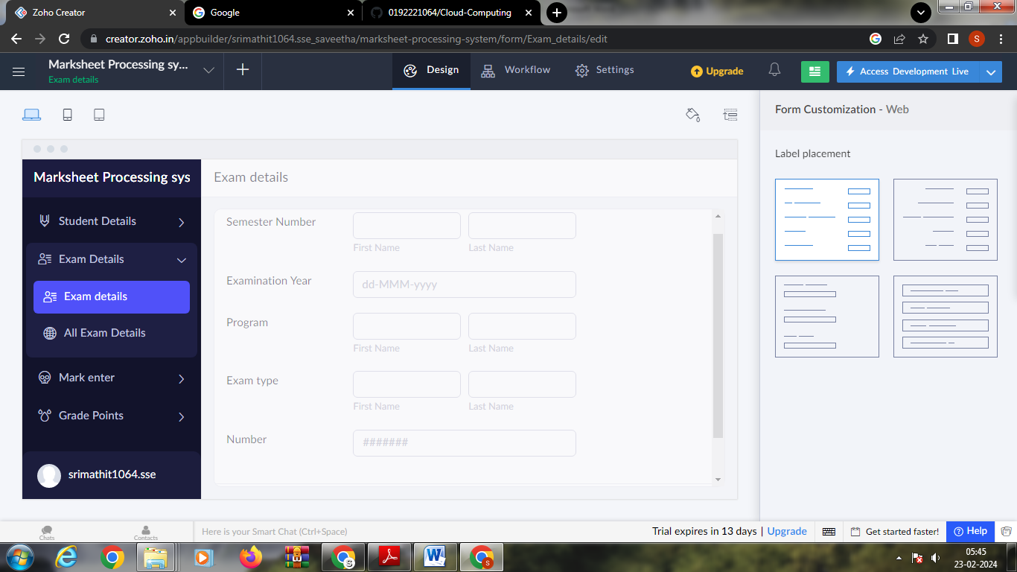

**Step 8: create next form for mark entry**

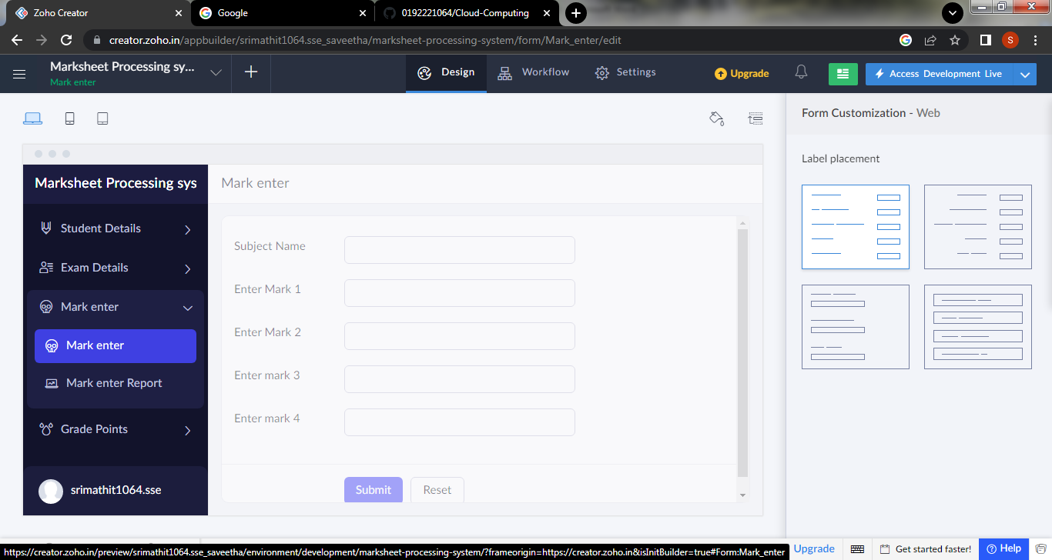

**Step 10: Create a new form for generating Grade points**

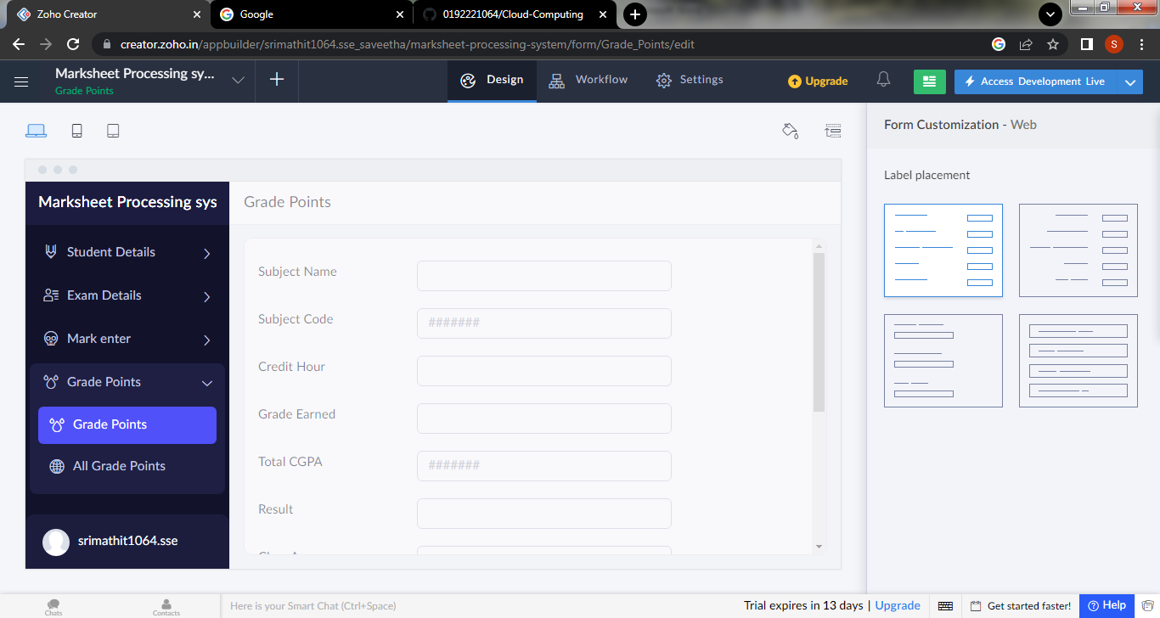

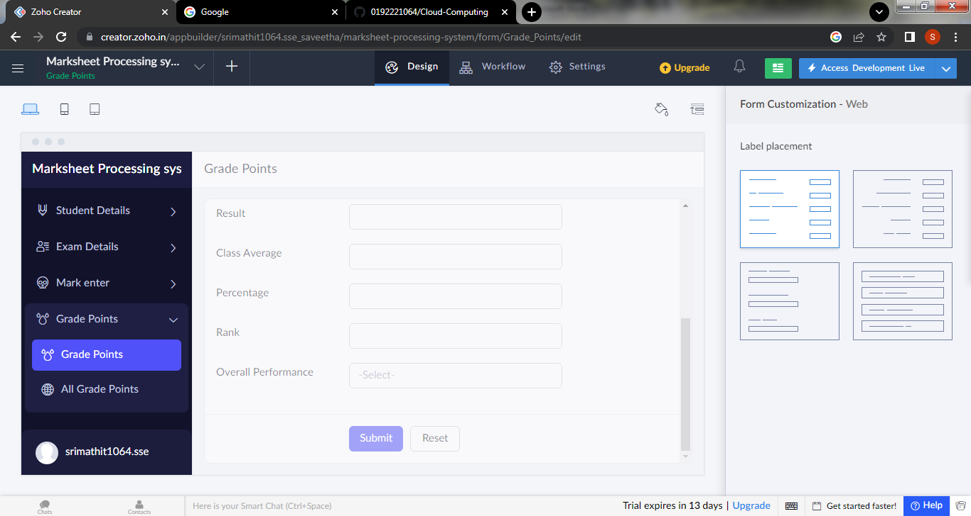

**Step 11: Click the access development live to view the output**

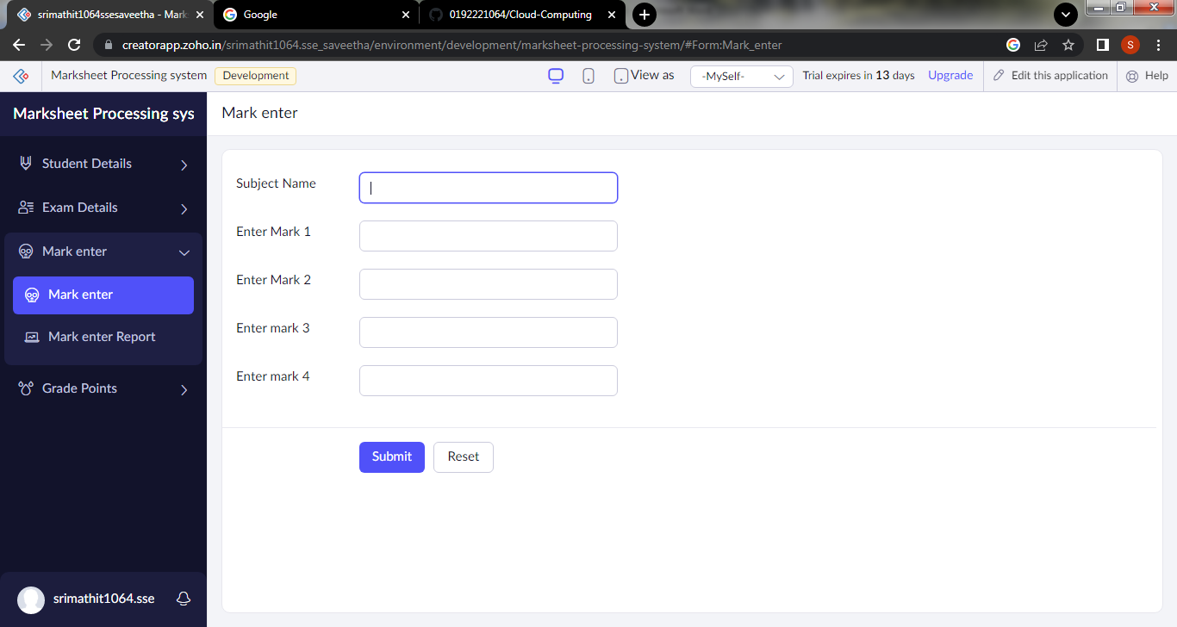

**Step 12: click the report to view the datas that are added**

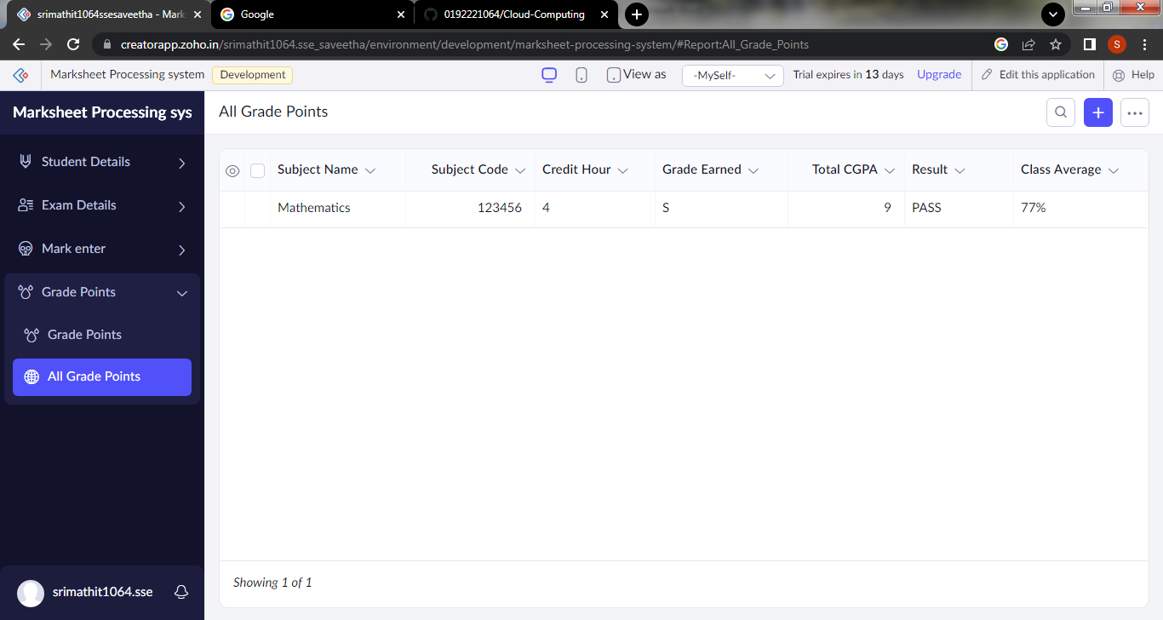

**Step 13: click the mobile icon to view the output in mobile format**

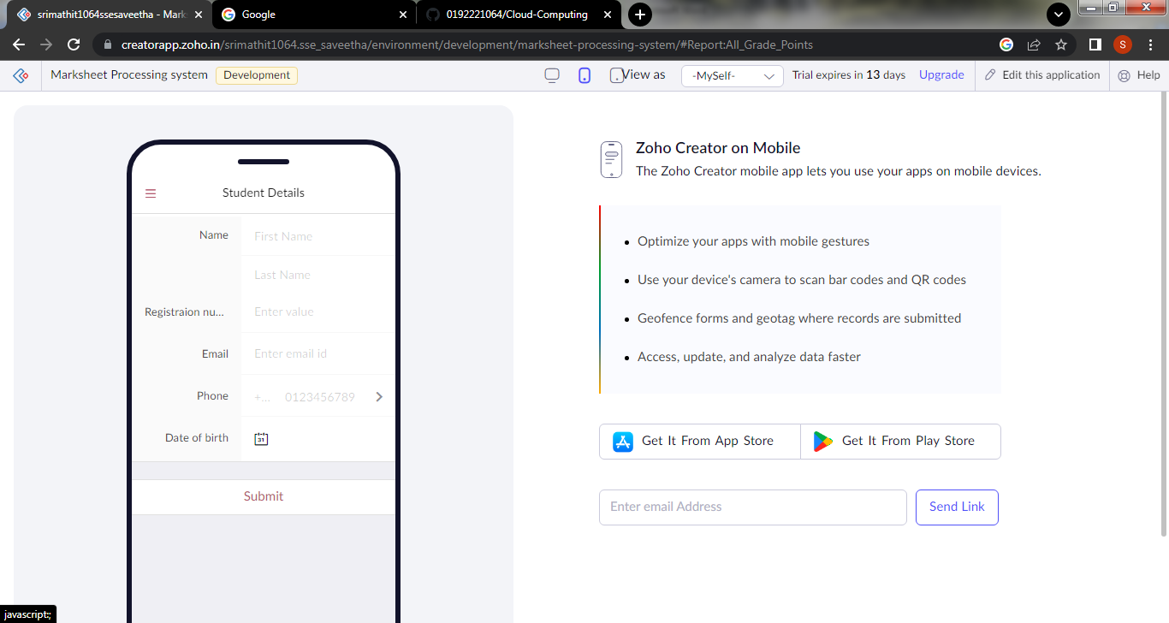

**Step 14: click the tablet icon to view the output in tablet form**

